EXPLORING A PARADISE IN THE DESERT OF THE MIDDLE EAST:
PROGRESSIVE STRATEGIES FOR ECONOMIC DEVELOPMENT IN DUBAI
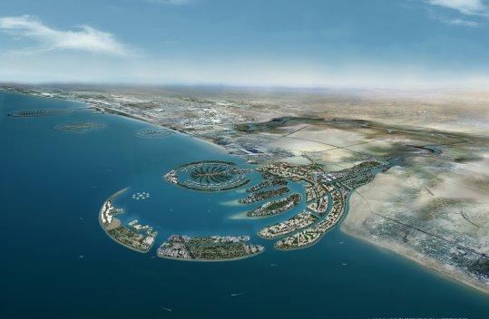
Despite the economic volatility of the Middle East, Dubai City is now emerging as the fastest growing city in the world. Dubai authorities play a critical role in the economic growth of the area by encouraging both tourists and investors from all over the world. Authorities’ goals are to develop world-class facilities for the city: the indoor ‘skiing in the desert’ facility, the luxury “seven star” hotel on the Dubai coastline, the world’s largest man-made island, and the world’s tallest building (2,651 ft) are only a few examples of the extraordinary progress they have already achieved. The purpose of this study is to look into Dubai’s economic development directed by Prime Minister Sheikh Mohammed (who is also the vice-president of the United Arab Emirates), and to explore the city’s strategic approach not only to stimulating the economy but also to providing luxurious attractions for the whole world to enjoy.

